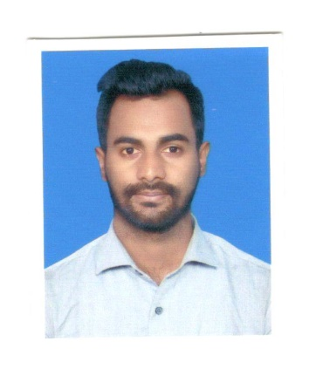**RESUME OF**

**YASIN AHMED**

Present Address # Ta-15, Middle Badda, Dhaka.

Cellphone # +880 1670 885064

Email # yasinahamedrefat@gmail.com

CAREER OBJECTIVES:

To become a dynamic and efficient Person as well as a management expert in any well know company to work for accomplishment the organization mission by shouldering adequate organizational responsibilities and to contribute the national development also. I want to be a perfect working hand of the organization to attain its goal and to build up my career.

EXPERIENCE:

1. Company Name :BLUE SOURCING LTD.

Company Location : Khilkhet ,Nikunjo-1, Dhaka.

Designation :Assistant Merchandiser.

Duration :11 November 2018 to 30 September 2019.

1. Company Name :AKB PRIONAR LTD.

Company Location : Road-12,Avinew-3,Mirpur DOHS, Dhaka.

Designation :Assistant Manager/Assistan of Chairman

Duration : 1 october 2019 to still Now.

1. Company Name :Best In Brand.

Company Location : Road-12,-Banani, Dhaka.

Designation :Marketing Assistant.

Duration : 2 feb to still Now.

EDUCATIONAL QUALIFICATION:

* Bachelor of Business Administration (B.B.A Professional)

Subject : Marketing

Passing year : 2019

University : Model Institute of Science and Technology

Result : 2.66

* Higher Secondary Certificate (H.S.C)

Institution : Gazipur City College.

Group : Business Study

Result : GPA: 3.70 on a scale of 5.0

Passing Year : 2013

* Secondary School Certificate (S.S.C)

Institution : MonipurHighSchool.

Group : Business Study

Result : GPA: 3.69 on a scale of 5.0

Passing Year : 2011

LANGUAGE & COMMUNICATION SKILL:

* Bangla - Mother Tongue.
* English- Strong command both in oral & Written.

COMPUTER PROFICIENCY:

* MS office application (Word, Excel, Power point & etc.)

PERSONAL INFORMATION:

Name : Yasin Ahmed

Father’s Name : Md. Jamal Uddin

Mother’s Name : Suma Begum

Date of Birth : 17 June 1995

Marital Status : Single

Religion : Islam

Gender : Male

Permanent Address : Gazipur, Monipur

Nationality : Bangladeshi

Place of Birth : Gazipur,Bangladesh

HOBBIES & INTEREST:

Reading Novels, Playing Cricket, and interest in traveling with different people and cultural program.

Signature